### MODIS Terra Data – EVI

#### Introduction

#### 

Terra was launched by NASA in 1999, aiming to understand Earth’s climate and climate change, especially the impact of human activities on the ecosystem over the years. MODIS (Moderate Resolution Imaging Spectroradiometer) on Terra satellite views the Earth’s surface on a daily basis, collecting data in 36 groups of wavelengths. MODIS has three distinct sets of spatial resolutions, 250m, 500m, and 1000m. The diverse range of sensing data with different spatial resolutions enables us to look at terrestrial, atmospheric, and ocean phenomenology on a global scale.

#### MODIS Bands

MODIS has 32 bands in total, which could be divided into three groups based on their resolutions. Group 1 (Band 1-2) and Group 2 (Band 3-7) look at the land/cloud/aerosol properties, and Group 3 (Band 8-36) looks at the water vapor, temperature, ozone, and cloud properties.

#### EVI

The dataset MODIS TERRA Daily EVI is derived from atmospherically-corrected reflectance in the red, near-infrared, and blue wavebands in satellite imagery, and then improved with higher sensitivity over high biomass regions by minimizing canopy-soil variations (Frazier). EVI can be used to quantify vegetation greenness, and provides a scope to look at vegetation states and processes (NASA, 2019).

Zimbabwe had the highest maize production and export in Africa back in the 1980s, while its maize yield has been fluctuating in recent years. Since EVI has a dynamic range and high sensitivity in dense vegetation, it becomes particularly suitable to map the cropping density in Zimbabwe. As high EVI values correspond to crops at their peak growth stage, we used maximum EVI values in each agro-ecological region during the growing season to observe the variation in crop growth in different time periods. Because the daily EVI values are too high-frequency to represent vegetation states, we aggregated the data into a monthly level as a better approach.

### Graphs

#### 1. Maximum EVI in the growing season

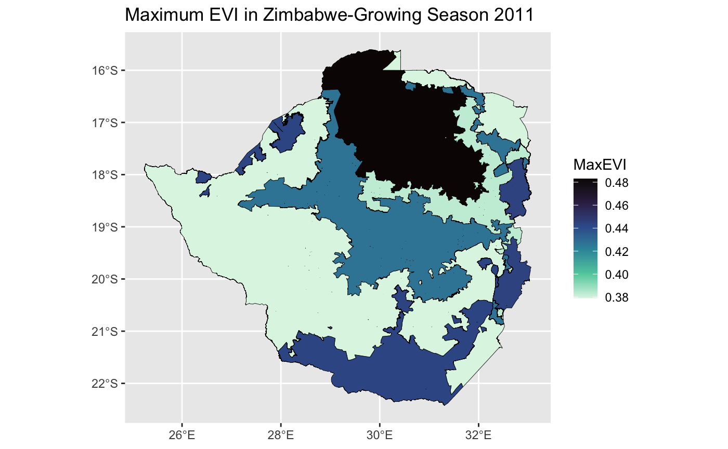

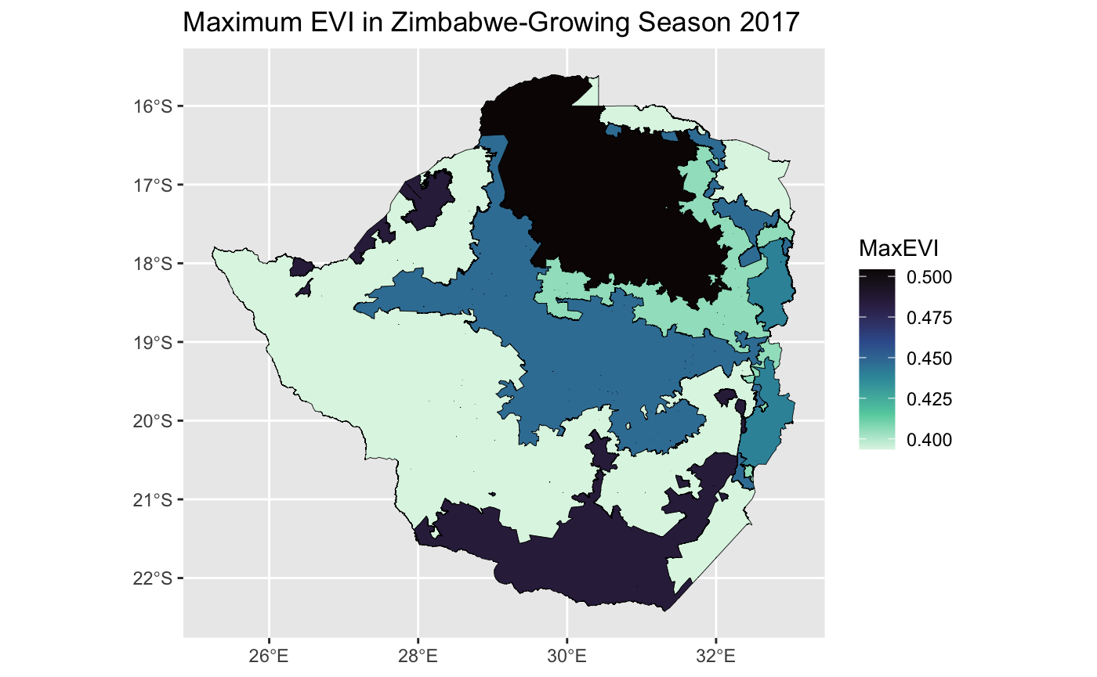

The graphs above show the maximum EVI (which corresponds to the density of crops) in Zimbabwe during growing season in 2011 and 2017, respectively. In both graphs, we could see that the maximum EVI value is at its highest in Region IIA, which, according to United Nations’ Food and Agriculture Organisation, is suitable for intensive farming. After Region IIA, Region V has the next highest maximum EVI value, which matches up with its farming system of extensive farming with cattle ranching. Region IV has the lowest maximum EVI value, and the FOA describes it as the “semi-extensive” farming region, suitable for resistant fodder crops (FAO, 2020).

Compare to the growing season in 2011, the deeper color shows that almost every region has a higher maximum EVI during the growing season of 2017. By solely looking at the data, we can also observe that the overall range of maximum EVI during the growing season in 2017 is also higher than in 2011, with the approximate minimum value being 0.4 (higher than 0.38 in 2011) and the approximate maximum value being 0.5 (higher than 0.48 from 2011).

#### 

#### 2. Time series graph

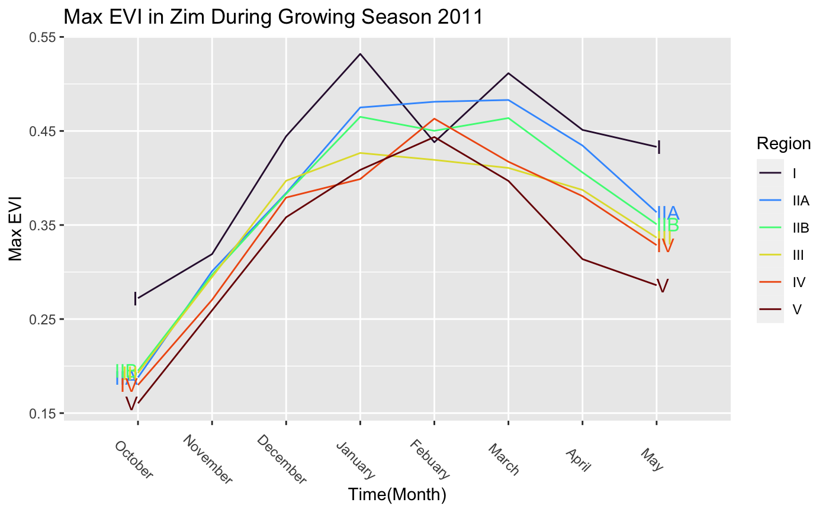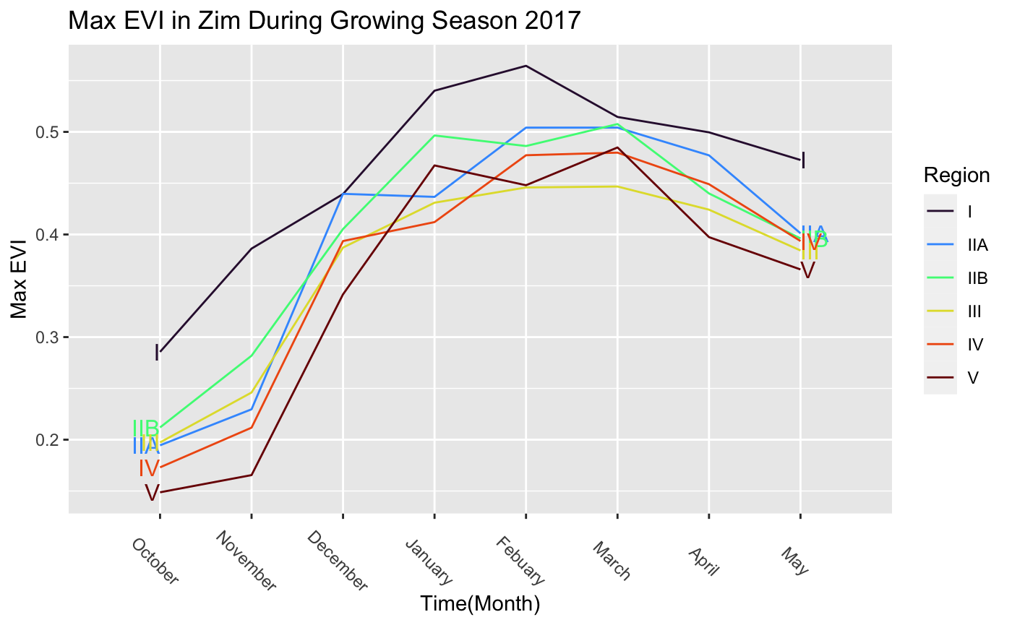

The line graphs above show the variation in maximum EVI in each agro-ecological region during the growing season in the years 2011 and 2017, respectively. We could see a general pattern of descending maximum EVI going from Region I to Region V, which matches up with the initial purpose of zoning. The maximum EVI is at its trough in October, and peaks from January to February. The reason for this could be due to the cropping cycle: farmers plow the field in October before sowing; the rainy season comes in November, with higher precipitation, crops grow gradually, and finally are at their peak growth stage during February and March, before the rainy season ends. Compare to the growing season in 2011, the highest maximum EVI value in 2017 is higher for almost all districts. This indicates significantly denser vegetation, thus a higher crop yield.